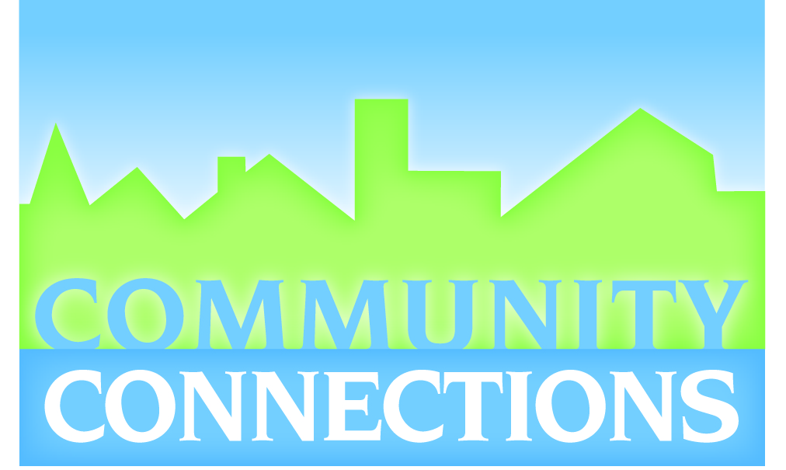
Thank you for your interest in Community Connections Mentoring. We provide local youth in kindergarten through seventh grade the opportunity to participate in one-on-one and group activities with an adult who has similar interests. Our mentoring program allows your child to be exposed to a variety of opportunities so that they can build on their unique strengths. As a part of Community Connections Mentoring, we also have a class in 6th grade called Impact Team with a unique mentoring/community service experiences throughout the year.

Our one-to one mentoring includes group activities and community service opportunities. Some of the group activities we have sponsored in the past have included horseback riding, roller skating, movie nights, a tour of KNOP TV station and swimming. All group activities are provided at no cost to you. In addition, our mentors and mentees receive free admission to the Children’s Museum and North Platte Recreation Center, only if they are in attendance with one another.

Typically, we encourage our mentors to spend at least four hours a month with their mentee. We ask our mentors to make a one year commitment to this relationship. Often times this connection lasts beyond this one year. All mentors in our program go through an application and background screening process before being placed into a mentoring relationship with a youth.

Mentors help re-enforce doing well in school, and making good decisions. Children who have had the opportunity to spend time with a mentor typically improve their grades and have increased self esteem. Our mentoring program offers a wonderful opportunity to enhance what you already do for your child by giving them additional exposure to another adult that wants to help your child be all they want to be.

As stated above, once a youth reaches sixth grade, they are encouraged to participate in Impact Team classes at Madison School once a week, which helps prepare them to make positive life choices, develop communication skills, deal with stress, and other skills to help them grow into responsible adults. This group is encouraged to participate in the afterschool trips to the NP Senior Center, local nursing home, or service projects monthly.

If you would like your child to participate in our program, please complete the enclosed application and return it the school office.

Community Connections Mentoring
121 N Dewey, Nebraskaland Bank downtown
308.696.0975
mentor@communityconnectionslc.org

Mailing address:
Community Connections Mentoring
PO Box 852
North Platte, NE 69103

Mentee Application for C.C. Mentoring and /or Impact Team (6th grade)
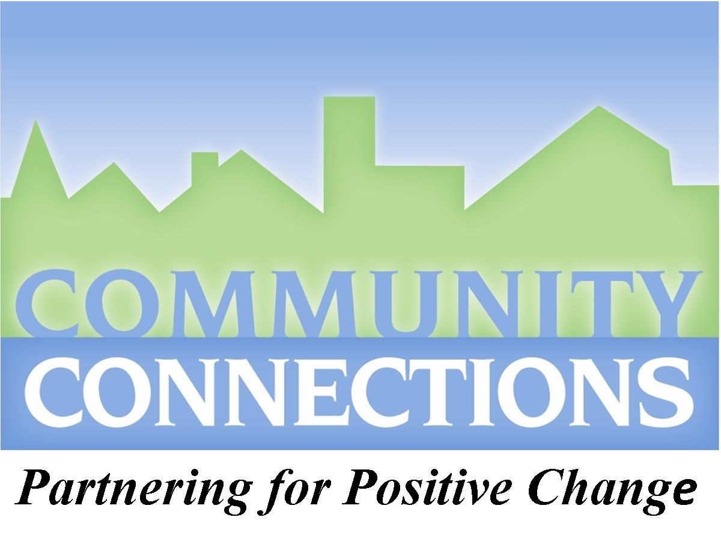
Please circle One-to-One Mentoring, Impact Team, or Both for this application.

Mentee/Student Information Referred by:______________________
Name: |  |  |  | Gender: |  | Date of Application:
Date of Birth: |  |  | Contact Number:
Home Address:

Grade: | School Attending: | Counselor: |  |  | Eligible for free /reduced lunch:   Yes  No
Race/Ethnicity:  African American  Native American  Caucasian  Latino/Hispanic  Asian
❑ Multi  Other: ______________________________

Parent/Guardian Information
Parent/Guardian Name: |  | Parent/Guardian Name:
Mothers Race/Ethnicity:   African American  Latino/Hispanic   Native American  Asian   Caucasian  Multi   Other: ______________________________ |  | Fathers Race/Ethnicity:   African American  Latino/Hispanic   Native American  Asian   Caucasian  Multi   Other: ______________________________
Highest Education Level: |  | Highest Education Level:
Current Employer and Occupation: |  | Current Employer and Occupation:
Work Phone: |  | Work Phone:
Cell Phone: |  | Cell Phone:
Email Address: |  | Email Address:
Emergency Contact Person: | Emergency Contact Phone Number: |  | Custody:
What is your household make up? (circle one) 2 Parents Single Parent Grandparent Guardian Other ___________

School Consent Form
In order to maintain quality services for your child, Community Connections staff and/or your child's mentor, may need to have contact with your child's teacher and/or school staff. Community Connections may contact the school in matters pertaining to your child and matching him/her with a mentor. Community Connections staff may contact the school to determine if there is anything that your child's mentor can do to assist him/her achieve success in school. Community Connections staff may contact your child's school teacher to complete evaluation surveys of the program. Community Connections may contact the school to obtain current school and grade level. Your child's mentor has the opportunity to meet with your child in the school setting, and may choose to do so. Any information gained by CC staff or your child's mentor will be kept confidential. This consent may be revoked at any time in writing and expires 90 days after the student has left the program.

____________________________________________________________ ______________________________
Parent or Guardian Signature Date

Impact Students Only Impact Team 6th grade meets after school on Wednesdays at Madison school. Monthly we ride the city bus to Senior Center or nursing home at 3:15 pm , where we visit with senior mentors until 4:30. My child will: Walk home ______ Be picked up:______ Other (I need help with transportation): ___________________________ __________________________________________________________
Parent/Guardian Signature and Date

Personal Health Information Disclosure Form
I authorize Community Connections Mentoring and their applicable business associates to disclose any pertinent Personal Health Information included in this application to my child’s mentor. I understand I may exclude the release of certain information under this agreement. Accordingly,
I wish to exclude the following information

I understand I am not required to authorize Community Connections Mentoring to provide access to my Personal Health Information and that I can refuse to sign this authorization. I understand that by refusing to sign this authorization I may not be able to participate in the services offered by Community Connections Mentoring.

____________________________________________________________ ______________________________
Parent or Guardian Signature Date

Authorization for Emergency Medical Treatment

I, ______________________________________ am the parent or legal guardian of _______________________________, a minor, who resides with me at the residence identified below. In the event all reasonable attempts to contact me (or my spouse) are unsuccessful, I authorize Community Connections or its authorized representative to consent to any necessary medical treatment, dental treatment or hospital care, including, but not limited to x-ray examination, anesthetic, medical or surgical diagnosis or treatment, to be rendered to the minor child under the general or special supervision and on the advice of a physician or surgeon licensed to practice in the State of Nebraska.

The following information is needed by any hospital or practitioner not having access to the child’s medical history:

Allergies: ______________________________ Date of last Tetanus shot: ______________________________

Medications being taken:

Physical impairments:

Other factors to which a physician should be alerted:

Primary Care Physician: ______________________________________________ Phone

Medical Insurance Provider: ________________________________________ Policy No.

_______________________________ ______________________________ ______________________________
Name of Child Parent or Guardian Address

Photo and Media Release
From time to time, requests are made to use pictures or other information of program participants in program presentations or publications. We need your permission before this can be done. Please indicate your decision by checking YES or NO.

My child ____________________________ CAN be photographed for publication. □ Yes □ No

My child ____________________________’s interests and background (no last names or detailed, personal information that would directly identify your youth will be used) CAN be shared for publication. □ Yes □ No

Please list all members of your household:
Name | Gender | Age | Ethnicity | Relationship to Applicant

What do the other members of your household think about your child getting a mentor?

Please read this carefully before signing:

Among other things, Community Connections provides both group and one-on-one mentoring activities. I agree to have my child attend these activities regularly and to keep my information updated so that I may be informed of all the fun activities provided by Community Connections.
In the consideration of permission granted to my minor child (or ward) to participate in the Community Connection mentoring program, I hereby release Community Connections, their agents, employees, officers, members or representatives from all actions, cause of action, damages, claims or demands which I, my heirs, administrators or assignees may have for all losses or damage to property, or all personal injuries known or unknown which my minor child has or may incur while the minor child is participating in the Community Connections mentoring program. In addition I agree that my child does not have any special needs that may involve care above what the program is able to offer or that may put any other child at risk.
I have read this release and understand all of its terms and I execute it voluntarily and with full knowledge of its significance.

___________________________________________________ ____/____/____
(Signature of Parent of Guardian) (Date)

1) (If your child is a boy) Would you like your child matched with (circle one): Man Woman Doesn’t Matter
(Girls are always matched with female mentors)

2) What times can your child meet with a mentor?
Before school Lunch After school After 5 p.m. Weekends Any time
3) Why would you like to have a mentor for your child?

4) What in particular brought you to Community Connections Mentoring, and how do you think your child will benefit by having a mentor?

5a) Has your child experienced any traumatic events (death in the family, abuse, divorce)? If yes, please provide details. _______________________________________________________________________________________________
b) Does your son or daughter have any type of behavioral, emotional, or physical challenges that may pose a special challenge to a volunteer? (Give examples as needed.) ______________________________________________________
__________________________________________________________________________________________________
c) To the best of your knowledge has your son or daughter experienced any form of emotional, physical, or sexual abuse in the past? If so, when and how do you feel it currently affects him or her?

d) Is your child currently on any type of medication? If so, please specify.

e) Is your child currently seeing a counselor or therapist?
6a) Are you or your spouse currently experiencing any medical and/or psychological conditions, or any physical or mental health problems?
b) Has any family member ever been diagnosed with any medical and/or psychological illness, disease, or disability?

c) Has any member of your family been involved with the police or juvenile justice system, or ever committed a crime to your knowledge? ______________________________________________________________________________
7a) How would you describe your child’s school performance and behavior? How does your child get along with teachers?

b) How does your son or daughter get along with other kids his or her age?

c) Is your child currently having any problems either at home or school? If yes, please provide details:

8) Please provide any additional background information that may be helpful in matching your child with an appropriate mentor:
______________________________________________________________________________________________________________________________________________________________________________________________

Mentee Interest Survey (To be completed by youth)
Circle all activities you enjoy:

Art | Auto Repair | Wrestling | Chess
Basketball | Billiards/Pool | Bicycling | Computers
Camping | Canoeing/Boating | Bowling | Golf
Animals | Drama/Acting | Reading | Crafts
Gymnastics | Handball | Fishing | Eating
Judo | Sightseeing | Horseback Riding | Movies
Photography | Music | Dancing | Running
Sailing | Shopping | Rollerblading | Soccer
Swimming | Parks | Board Games | Water Skiing
Skateboarding | Tennis | Volleyball | Baseball
Spiritual | Volunteer Work | Cards | Gardening
Library | Video Games | Community Group Work | Other

List any other areas of special interest:

What are some favorite things you like to do with other people?

What are your favorite subjects in school?

What person do you admire most and why?

If you could learn something new, what would it be?

Describe your ideal Saturday.

On a scale of 1 to 5, how important is it to you to have a mentor:

It’s not very important It would be nice I really, really want a mentor
     1  2  3  4  5

Please mail application to: Community Connections, PO Box 852, North Platte, NE 69103
or you can drop it off in person to your school office or 121 N Dewey, Suite 109, NebraskaLand Bank building
If you have any questions about this application, please call 308.696.0975.
mentor@communityconnectionslc.org

